Belarusian State University of Informatics and Radioelectronics

Misunderstanding between two intelligence

Maksim Truhanovich,

1st year student

group 853501

Research adviser:

Yana V. Liakh,

Lecturer

**Contents**

Introduction ………………………………………………………………………. 3

History of artificial intelligence ………………………………………………….. 3

Approaches .……………………………………………………………………… 3

Development ……………………………………………….…………………….. 4

Solution …………………………………………………………………………... 5

Two camps for and against ………………………………………………………. 5

References ………………………………………………………………………... 6

**Introduction**

Misunderstanding in the description is a look at the artificial intellect, as an opponent who steals your job, or a robot, unable to do anything except copying, something without a soul and feelings - “terminator”. However, in reality, it is an assistant or employee, which creates more space for self-development .Now more than ever before the diversity increases and the quality of creativity improves, but this goes into the background because of the race for the workplace.

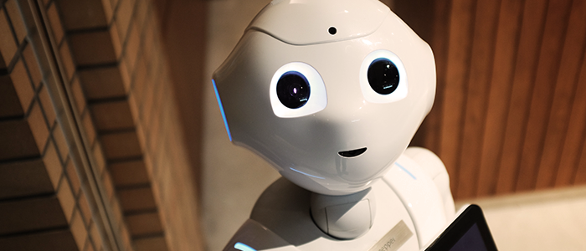

Today, as you could understand, I will not speak about countermeasures or ways to prevent the development of artificial intelligence, this is impossible, but how we came to this transition and how to make it right. Because AI develops faster then ever before and there’s no time to think about what would be if…

So two important definitions: Artificial - made or produced by human beings rather than occurring naturally, especially as a copy of something natural. Intelligence - the ability to acquire and apply knowledge and skills.

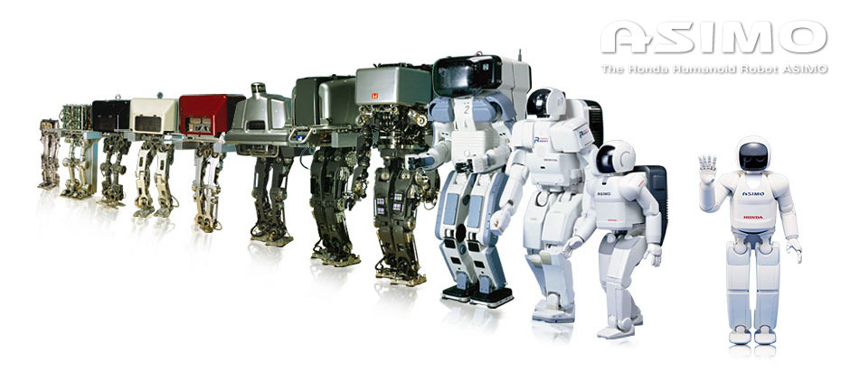**History of artificial intelligence**

In 1956, American computer scientist John McCarthy organized the Dartmouth Conference, at which the term ‘Artificial Intelligence’ was first adopted. 4 years later researchers emphasized developing algorithms to solve mathematical problems and geometrical theorems. In the late 1960s, computer scientists worked on Machine Vision Learning. Moreover, WABOT-1, the first ‘intelligent’ humanoid robot, was built in Japan only 12 years after. Then was ‘AI Winters’ for 20 years. But with better computers in 1997, IBM’s Deep Blue became the first computer to beat a reigning world chess champion, Garry Kasparov.

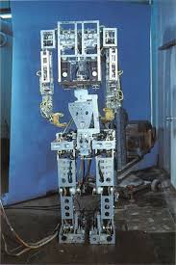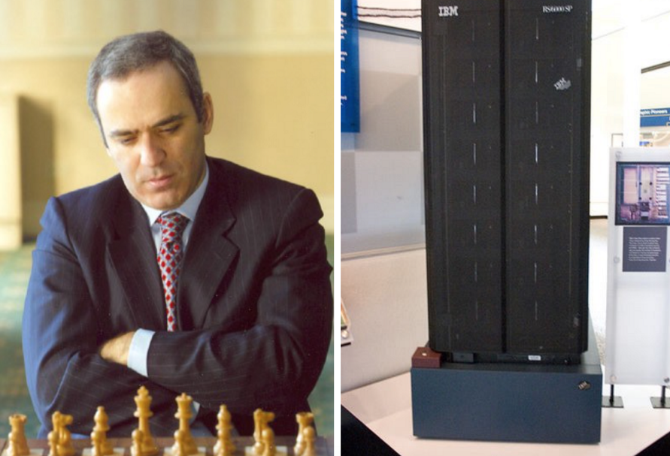

Some AI funding dried up when the dotcom bubble burst in the early 2000s. The biggest explosion of techniques was in 2011: Big Data, Deep learning, Artificial general intelligence that brought us image recognition and restoration, speech recognition and brain emulation.

**Approaches**

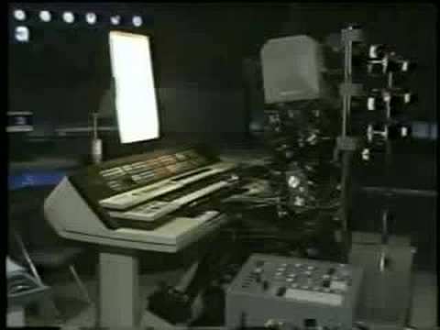 There were many different approaches to create artificial intelligence such as logic-based (find the essence of abstract reasoning and problem solving, regardless whether people used the same algorithms), anti-logic (there is no simple and general principle), neural networks ("learn" to perform tasks by considering examples) , Knowledge-based (which was emulating decision-making , which had huge data collection), and etc.

Artificial intelligence, which relies on data, with definition:” The more, the better” and technologies brings us to two giants in these spheres.

The US that leads the era of discovery and China that leads the era of implementation, we are now in an amazing age where the dual engine of the two superpowers are working together to drive the fastest revolution in technology that we have ever seen as humans.  It will bring immense challenges in terms of potential job replacements. AI completely replaces the individual jobs in the assembly line with robots. Moreover, it's not just in factories, but truckers, drivers and even jobs like telesales over the next 15 years are going to be gradually replaced by artificial intelligence. Only the creative jobs are the ones that are protected, because AI can optimize but not create.

**Development**

In the next 10 years, these physical applications (I would also include AR / VR in this since they aim to augment these physical applications) are going to be where AI plays the biggest role. So it will takes more and more casual jobs from us and change vector of our development to creativity.

But what's more serious than the loss of jobs is the loss of meaning, because the work ethic in the Industrial Age has brainwashed people into thinking that work is the reason they exist, that work defined the meaning of their lives. And maybe some of you are a prime and willing victim to that type of workaholic thinking.

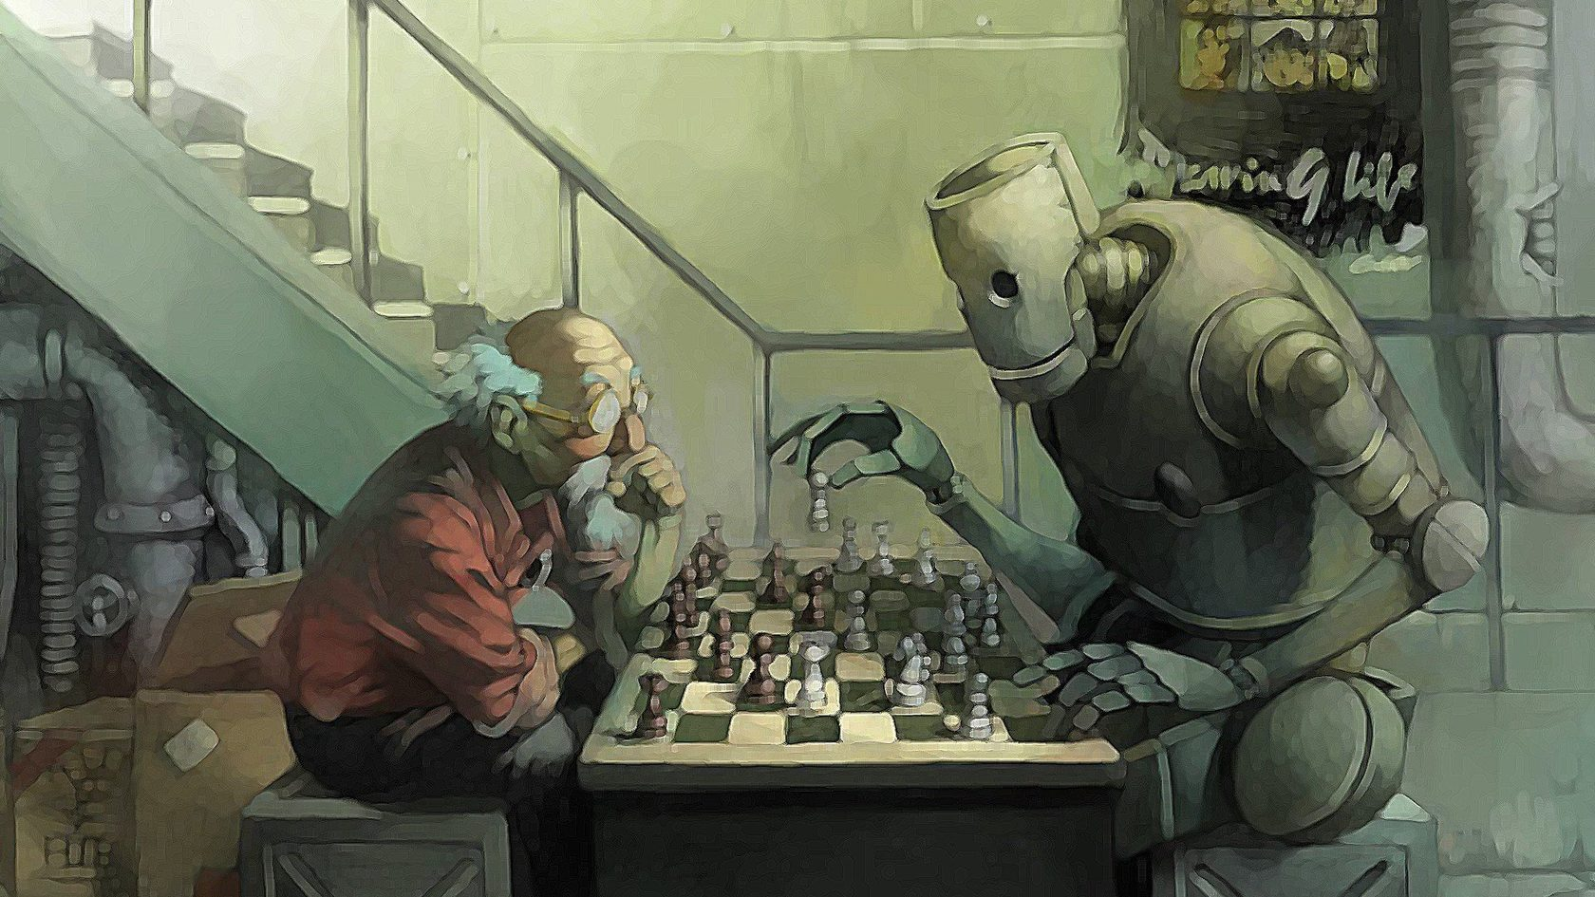**Near the future**

Despite what science fiction may portray, I can responsibly tell you that AI has no emotions. In 2017, when AlphaGo defeated the world champion Ke Jie, while Ke Jie was crying and loving the game of Go, AlphaGo felt no happiness from winning. It’s going to be worth a lot. By 2020, “truly insight-driven businesses” will be benefiting from $1.2 trillion more every year than their “less-informed peers,” according to Forrester. Some people call this artificial intelligence, but the reality is this technology will enhance us. Therefore, instead of artificial intelligence, I think we will augment our intelligence.

**Solution**

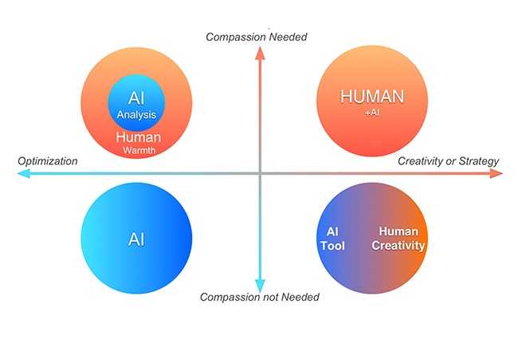So how do we differentiate ourselves as humans in the age of AI? So as AI takes away the routine jobs, I like to think we can, we should and we must create jobs of compassion. You might ask how many of those there are, but I would ask you: Do you not think that we are going to need many social workers to help us make this transition?

Do you not think we're going to need 10 times more teachers to help children find their way to survive and thrive in this brave new world? And with all the newfound wealth, should people not also make labors of love into careers and let elderly accompaniment or homeschooling become careers also?

**Two camps for and against**

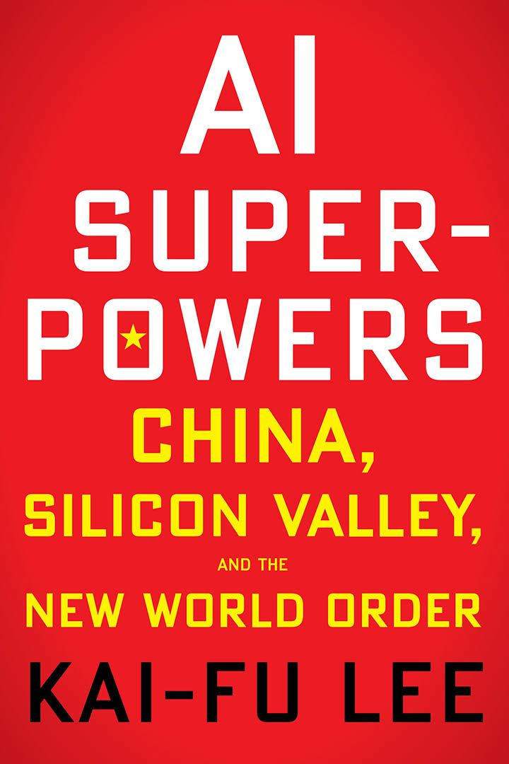

One “for” is represented by Kai-Fu Lee One of the most prominent figures in the Chinese internet sector; he was the founding director of Microsoft Research Asia, serving from 1998 to 2000; and president of Google China, serving from July 2005 through September 4, 2009. A­­­­nd his famous book AI Superpowers: China, Silicon Valley, and the New World Order. He created a website, *Wǒxuéwǎng* (literally: 'I learn Internet') dedicated to helping young Chinese people achieve in their studies and careers, and his "10 Letters to Chinese College Students" have spread widely on the web.

To the surprise against roaster will be represented by Elon Musk – founder of Space X, co-founder of PayPal and “Boring Company” which construct loop tunnels.

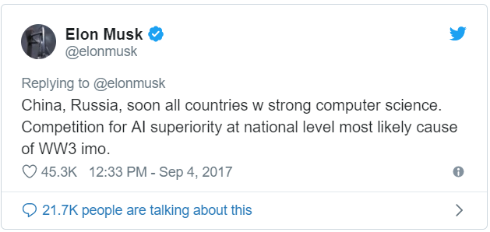There are no special article made by him , to fully represent his position , only twits ***\*\**** or interviews were all his ideas try to drive from point were AI is helpful to point were dangerous people ( dictators especially ) will steal this new made super technology and bring destruction to hole world .

**References**

1) Well-built site about AI [Electronic resource]. – 2018 – Mode of access: <https://www.vegasslotsonline.com/news/artificial-intelligence/>/ Date of access: 27.03.2019.

2) Solution and “leader of “for” chamber” [Electronic resource]. – 2018 – Mode of access: <https://www.ted.com/talks/kai_fu_lee_how_ai_can_save_our_humanity>/ Date of access: 25.03.2019.

3) History and Approach of AI [Electronic resource]. – 2018 – Mode of access: <https://en.wikipedia.org/wiki/Artificial_intelligence>/Date of access: 20.03.2019.