BELARUSIAN STATE UNIVERSITY

OF INFORMATICS AND RADIOELECTRONICS

**Belarusian features of Green Marketing**

Darya Andrievskaya,

1st year student,

Group 974002

Research Adviser:

Marina V. Ladyjenko,

Senior Lecturer

**TABLE OF CONTENTS**

INTRODUCTION…………………………………………………...……… 3

1. What is Green Marketing? ..................................................................... 4

2. Green Marketing in foreign practices……………………………………..5

3. Green Marketing in Belarus……………………………………………….5

CONCLUSION……………………………………………………………….6

REFERENCES……………………………………………………………….7

**INTRODUCTION**

Green marketing is a marketing strategy of producing and retailing environmentally friendly products and services. Over the past few years it became popular as more people become concerned about the environment and its issues.

Green marketing touches every aspect of a business, from production and packaging to advertising and public relations. Green marketing not only focuses on protecting the environment by promoting green products but also focuses on how to sell these green products to earn the most profits. Companies that have strong and reliable green marketing strategy are gaining loyal and knowledgeable customers.

This article is aimed to reveal such topics as:

* The definition of green marketing, its advantages and disadvantages;
* Foreign practices of green marketing and their results;
* Belarusian features of green marketing, its progress and issues in Belarus.

1. **What is Green Marketing?**

AMA defines green marketing as the marketing of products that are presumed to be environmentally safe, it incorporates several activities such as product modification, changes to production processes, packaging, advertising strategies and also increases awareness on compliance marketing amongst industries [1].

In the last decade, consumers have become more enlightened on environmental issues. Green marketing refers to selling product or rendering services based on environmental benefit. It came into existence in late 1980s and early 1990s. The "Green consumerism" movements in the U.S. and other countries have struggled to reach critical mass and influence. However, public opinion polls taken since the late 1980s have shown consistently that a significant percentage of consumers in the U.S. and elsewhere profess a strong willingness to favor environmentally conscious products and companies. Despite all challenges, Green marketing is growing rapidly and consumers are willing to pay a lot for green product [2].

What are the goals of green marketing?

* Implementing sustainable business practices
* Demonstrating social responsibility
* Reducing expenses (packaging, transportation, energy/water usage, etc.)
* Demonstrating how safe and mindful products or services are

Advantages:

* A company can enter new markets when it brings attention to positive environmental impact.
* Gain more profit from green marketing
* Green marketing brings a competitive advantage
* Raise awareness on important environmental or social issues
* It makes the company out the line, which help them to gain profit in a long time.

The most important advantage of green marketing is that eco-friendly goods have a competitive advantage over other firms selling non-eco-featured goods.

Main disadvantages:

* Change leads to costs
* Costly green certifications

Changing marketing actions takes time and the development of a new strategy, which typically translates into increased costs. And to commercialize products as “green”, depending on your industry you might have to go through a long and pricey process to obtain the environmental certifications.

1. **Green Marketing in foreign practices**

Nowadays a lot of countries and retailers are concerned about the problem of plastic pollution. We all use plastic packages every day in shops, malls, coffee shops, fast food cafes and etc. And only a few knows, that actually not all plastic can be even partly recycled. Almost 90 % of all produced plastic, however, is not being recycled. Usually it’s just thrown away or burnt that means it’s just polluting the environment. Recycling systems can’t keep up with the enormous volume of produced plastic garbage.

However, international companies are trying to solve this urgent problem. For example, IKEA the Swedish furniture retailer already declared about gradual liquidation from plastic packages and tubules and its aim to get rid of all used plastic. And in Germany some supermarkets like Rewe, Real, Lidl and KiK have already refused from plastic packages. Now near cashboxes you can find only thick paper or canvas package bags which you can use repeatedly. Recently, the European Commission has proposed banning disposable dishes, cotton buds and balloon sticks in the EU since 2021. And under a special "supervision" to place another ten products in which there is disposable plastic.

According to the proposals of the European Commission, different measures will be applied for different products. Products that are easy to find a reusable alternative will be banned. If there is no alternative, then at the national level, each country will have to limit its use, as well as take care of the design and labeling and oblige manufacturers to “take care” of their garbage.

1. **Green Marketing in Belarus**

So, what about our country? Unfortunately, the amount of waste has doubled in past 9 years. As an example in 2010 approximately 11 million cub. meters of waste were produced in Belarus, and in 2019 - almost 22 million cubic meters of waste. At the same time over the last decade today almost 94% of population in Belarus has opportunity to separate collection of waste. Our country as well as other world is concerned about plastic problem. So what are our ways to fight with plastic waste?

For example, our country will ban disposable dishes in food service establishments since 2021. As well as in Europe our Belarusian supermarkets like «Vitalyr» and «Evroopt» have already been using some thick paper packages or canvas package bags. However, usually they’re quite more expensive than usual plastic ones and every customer can afford to buy them. So basically the main problem is that producing eco packages is pretty expensive for retailers to produce and so it will be a bit more expensive for customer to buy it.

The other problem can be that common customers are simply don’t know much about different types of packages. Along with paper packages there’re corn starch packages. They’re completely decomposing, do not leave plastic prints on nature, and under certain conditions, fertilizer can be made from them. Kinglet group of companies in Logoisk started producing unique packaging for our country. The new Kinglet bio bags are made from corn starch-based material from plant leaves (pic. 1).

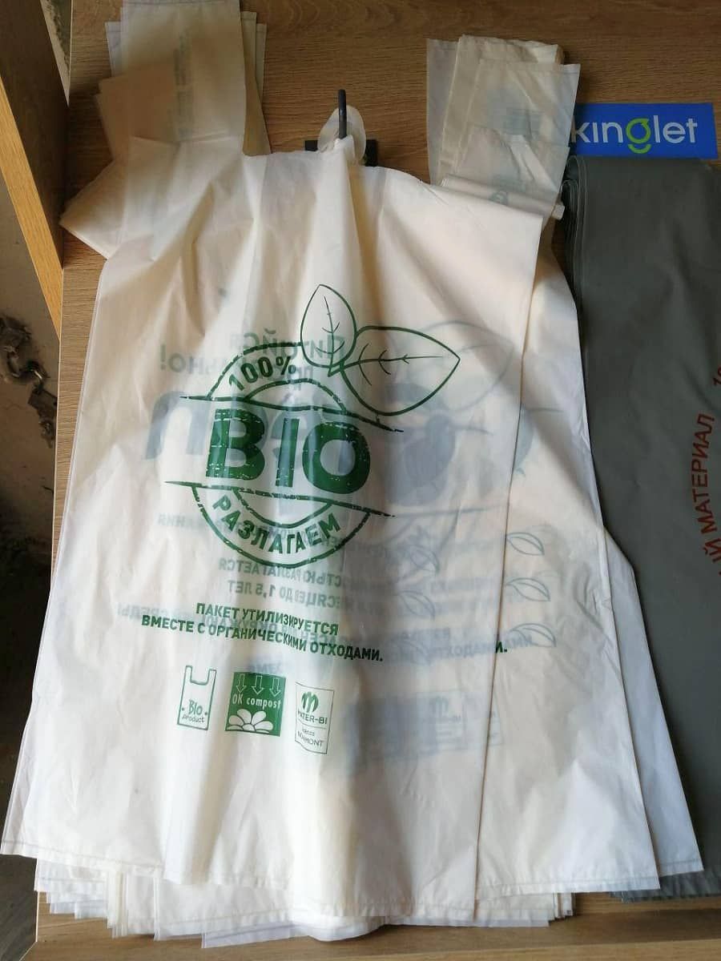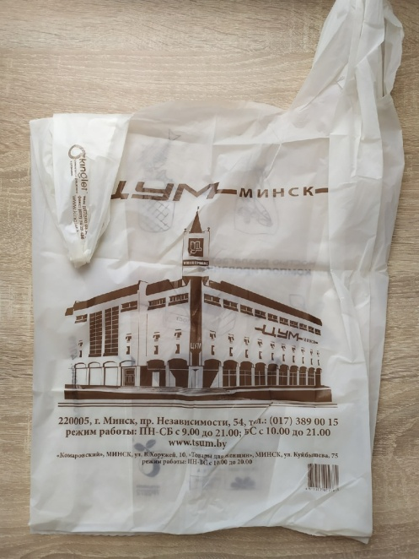

Pic. 1. Kinglet bio corn starch-based bag

After a year, along with organic and food waste, such packaging decomposes and disappears. If you create special conditions for industrial composting (the process of creating fertilizer), the packages will become part of the nutrient for the garden after 180 days, or even less. The cost of such a “T-shirt” shape package will be more expensive than polyethylene, but half of the price of paper ones (the retailer determines the exact price: from 0.30 to 0.40 bel. rubles). Such corn starch packages are already used by supermarkets like “Korona” and even by central department store “TSUM” in Minsk.

At this point there’re a few steps how to make our Belarusian Green Marketing and the problem of using plastic packages more significant:

* Clearly identify which products need packaging and which do not.
* Add to supermarkets sections with goods without packaging.
* Do not prevent customers from using their packaging if visually it is clean.
* Educate people about plastic packaging problem and show them that ‘eco-packages’ are really not that expensive and you can use them repeatedly. Create environmental and educative projects for school and university students.
* Invest in developing recyclable packages for Belarusian retailers and manufacturers
* Refuse to use very thin plastic packages as they can’t be recycled. The trouble with most of our packaging bags is that they are too thin to be collected on a sorting line and sent to a processor. For this reason, in many European countries, a threshold for the thickness of packaging bags is set below which their use and sale are prohibited.

**CONCLUSION**

There’re still some issues we should work on hardly. To develop stable green marketing strategy retailers and the government should work in cooperation. If people are educated and won’t be indifferent to these problems we’ll help to make better environment for ourselves first. I think Belarus has a great potential and government’s support to make Green Marketing one of the most developed areas in our country and in the world.

**REFERENCES**

[1] “Wikipedia”. Green Marketing. — Mode of access: <https://en.wikipedia.org/wiki/Green_marketing>. — Date of access: 20.03.2020.

[2] “American Marketing Association”. Definition of Marketing. — Mode of access: <https://www.ama.org/the-definition-of-marketing-what-is-marketing/>. — Date of access: 20.03.2020.